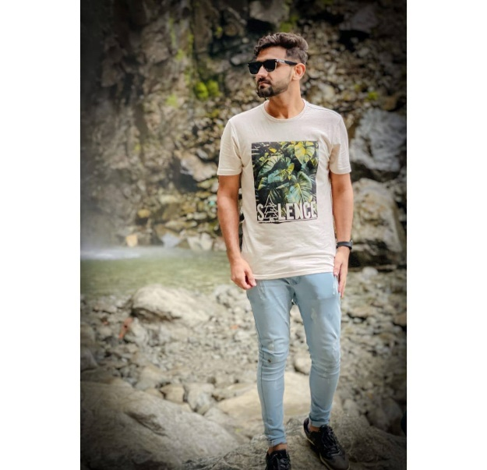

**Muhammad Soban Rasheed**

Ecommerce Project Manager



Janjuasoban71@gmail.com

Rawalpindi Pakistan



Sobansju.cyou

0335-0587032



**EXECUTIVE SUMMARY**

**LANGUAGES**

Dedicated professional with proven performance in management, leadership and communication. Detail-oriented in problem-solving and planning. Ready to make an immediate contribution to your organization.

My Aim of life is to become a full stack devloper and provide Quality Work.

Urdu

u

English

**HARD SKILLS**

**Projects Web development And JA**

Html

**Toursim Mangement System**

This project was made by me during my semister project. It includes all the functionality like login create new account functionality then it include all the trips available with complete accomudation detail and complete booking can be done.It also have crud operation admin can handle .It was code using (Html, Css , Bootstrap, Javascript, Mysql and Php)

Botstrapp

Javascript

Css

Mysql

Php

**Ecommerce Website:**

This Website include all the functionality and all the thing in an professional ecomerce website have. It has all variety for male and femlae with cart system. We can add to cart and then we order all the system. It also generates a slip after complete submission It was code using (Html, Css , Bootstrap, Javascript, Mysql and Php(laravel)).

**SOFT SKILLS**

* Team Leadership
* Problem-Solving
* Lean Startup Thinking
* Teamwork
* Positive Attitude
* Excellent Communication

**Library Mangement System:**

It was code using (Java Gui). It Include Admin portal and Student portal. In Admin portal admin can only delete and update record. While student can Buy book,isssuebook with date if Late 2% tax on per day will be counted



**Hobbies**

**Bachelor IN COMPUTER SCIENCE | 5th Semister**

Comsats University Islamabad (Abbottabad Campus)

**FSC(PRE Enginnering) | 2018**

Fauji Foundation College Matore

**ACADEMIC BACKGROUND**

* Reading Novels
* Photography
* Coding
* Photo Editing
* Playing Basketball